Customs Technology that Reduces the Cost of Doing Business

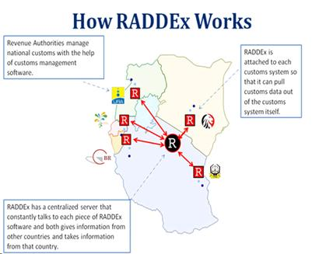

The East Africa Trade Hub is working with the East African Community (EAC) Secretariat, EAC Revenue Authorities, and the Federation of East African Freight Forwarders Associations to mobilize RADDEx (Revenue Authorities Digital Data Exchange) use among the private sector. The benefits to RADDEx are far reaching – including:
RADDEx reduces customs entry redundancy and processing time, and could save clearing agents up to two hours at every border. The transit entry form for through transit has 38 information fields that clearing agents need to fill at every border. RADDEx reduces the number of fields that need to be filled to three.
RADDEx enables the advance clearing of goods across borders. Once a truck has lodged its initial customs declaration at port of entry, all information regarding cargo is instantaneously relayed to the clearing agent at the border. That agent can immediately start clearing that cargo while the truck is still in transit. Advance completion of customs declarations can constitute a 50 percent reduction in time at borders. If the average clearance time at the Malaba border is four hours, truckers using RADDEx should be able to clear the border in two hours. Advance clearing is similar to checking-in online for a flight.

